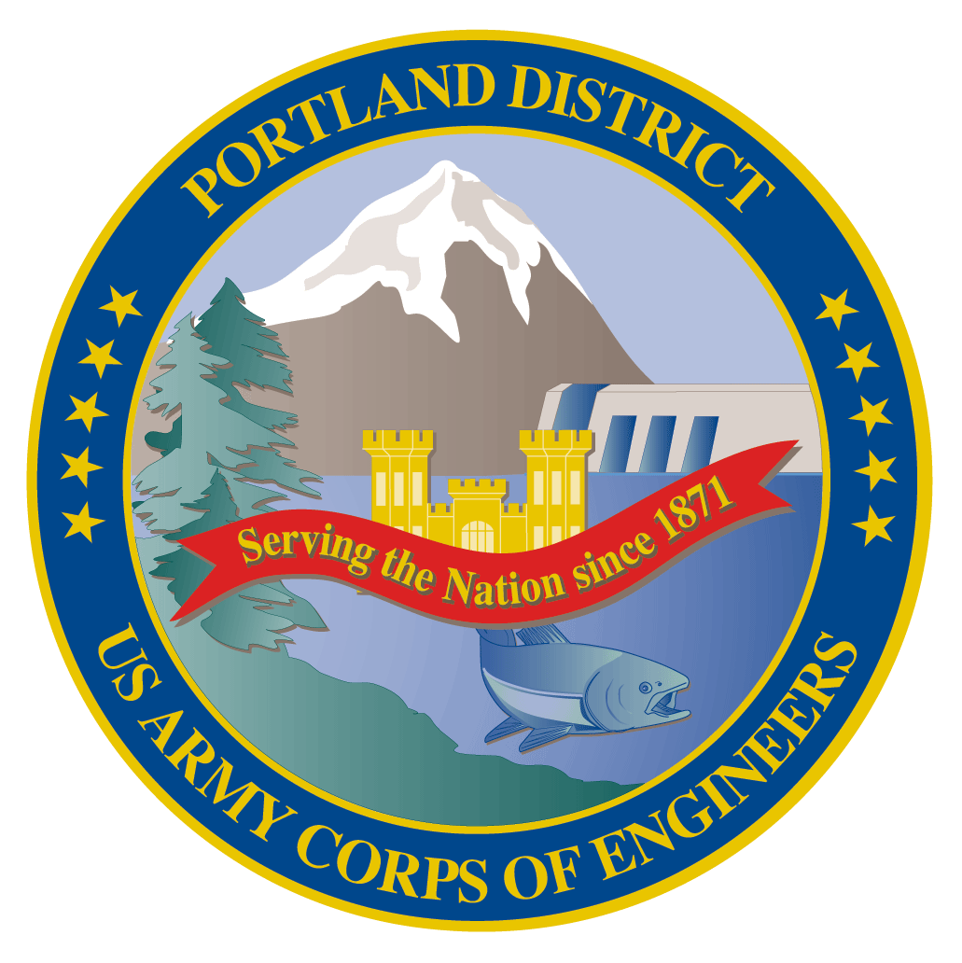
Lower Columbia River Fish Facility Design Review Work Group (FFDRWG)

USACE, Portland District
  - May 2023 Agenda
Meeting Date: May 4, 2022, 09:00-12:00
Join Meeting: https://usace1.webex.com/join/jacob.macdonald
Join by phone (audio only, no Webex): (844) 800-2712 | Access Code: 1995 00 9820

FFDRWG Meeting Files:
https://pweb.crohms.org/tmt/documents/FPOM/2010/FFDRWG/FFDRWG.html

Introductions
FFDRWG members:
BPA
Scott Bettin
Kim Johnson
Christine Petersen
Greg Smith
Leah Sullivan
Ben Hausmann
NOAA
Blane Bellerud
Gabriel Brooks
Trevor Conder
Claire McGrath
Kelsey Swieca
Chris Magel
Kinsey Frick
USFWS
Dave Swank
Shelby Fowler
States
Erick Van Dyke (ODFW)
Charles Morrill (WDFW)
Jonathan Ebel (IDFG)
CRITFC/Tribes
Tom Lorz (CRITFC)
Blaine Parker (CRITFC)
Tom Skiles (CRITFC)
Laurie Porter (CRITFC)
Greg Silver (CRITFC)
Casey Baldwin (CTCR)
Michael Karnosh (CTGR)
Lawrence Schwabe (CTGR)
Torey Wakeland (CTGR)
Aaron Jackson (CTUIR)
Ralph Lampman (YN)
NPCC
Leslie Bach
Kris Homel
FPC
Erin Cooper
PSMFC
Alan Brower
Darren Chase
Roger Clark
Mark Leonard
Scott Livingston
Nicole Tancreto
Don Warf
CENWD
Doug Baus
Tim Dykstra
Dan Feil
Cindy Studebaker
Lisa Wright
Sean Tackley
Ian Chane
CENWW
Chris Peery
Steve Juhnke
Steve Sipe
CENWP-OD
Andrew Derugin
Jeanette Wendler
Tucker Gossett
Bob Cordie
Jeffrey Randall
Eric Grosvenor
Michael Lotspeich
Laura Rickets
Tammy Mackey
Robert Wertheimer
Patricia Madson
Darren Gallion
Kyle Tidwell
CENWP-PM
Jim Adams
Jeff Hicks
Erin Kovalchuk
Brad Eppard
Nathan McClain
Jake Macdonald
Jon Rerecich
Ida Royer
David Trachtenbarg
Scott Fielding
Rebecca Cates
CENWP-ENC
Adam Jones
Adam White
Brandt Bannister
Shari Dunlop
Chris Motti
Steve Schlenker
Max Wilson-Fey
Collin Porter
Dan Penn
Aaron Litzenberg
Mehdi Roshani

Action items from previous meetings
- Review notes from 2023-03-02 meeting

Topics for FFDRWG Discussion/Review/Coordination
- BON1 adult lamprey passage improvements – Erin Kovalchuk (PM), Adam White (TL), Andrew Derugin (FC)
  - 90% DDR available for FFDRWG review at: NWP FFDRWG and SRWG documents (https://pweb.crohms.org/tmt/documents/FPOM/2010/FFDRWG/FFDRWG.html)
  - Contract is advertised on SAM.GOV for construction Winter 2023-2024
  - Bradford Island LPS and wetted wall counting improvements – Madson
- BON2 control section redesign – Erin Kovalchuk (PM), Shari Dunlop (TL), Andrew Derugin (FC)
  - 60% DDR is available for FFDRWG reference (not for comment) at: NWP FFDRWG and SRWG documents (https://pweb.crohms.org/tmt/documents/FPOM/2010/FFDRWG/FFDRWG.html)
  - 90% DDR will be available for FFDRWG review & backcheck on or before 1-June
  - PDT will provide an overview of changes from 60% to 90% at our 1-June FFDGWG meeting
- TDA adult lamprey passage improvements – Erin Kovalchuk (PM), Adam White (TL), Jake Macdonald (FC)
  - 90% DDR available for FFDRWG review at: NWP FFDRWG and SRWG documents (https://pweb.crohms.org/tmt/documents/FPOM/2010/FFDRWG/FFDRWG.html)
  - Contract is advertised on SAM.GOV for construction Winter 2023-2024 - White
- JDA adult lamprey passage improvements – Erin Kovalchuk (PM), Adam White (TL), Jake Macdonald (FC)
  - 100% DDR available for FFDRWG review at: NWP FFDRWG and SRWG documents (https://pweb.crohms.org/tmt/documents/FPOM/2010/FFDRWG/FFDRWG.html)
  - In-house construction, no 90% DDR and no BCOES. Construction in Winter 2022-2023.
  - Construction progress update (Lotspeich)
- BON2 FGE – Oseji Azuka (PM), Max Wilson-Fey (TL), Jon Rerecich (FC)
  - Construction progress update - Rerecich
  - Biological test AFEP research summary - Rerecich
- TDA Backup AWS debris management – Erin Kovalchuk (PM), Mehdi Roshani (TL), Jon Rerecich (FC)
  - Progress update – Rerecich
  - 60% EDR alternative evaluation available for FFDRWG reference at: NWP FFDRWG and SRWG documents (https://pweb.crohms.org/tmt/documents/FPOM/2010/FFDRWG/FFDRWG.html)
- BON PIT Detection – Erin Kovalchuk (PM), Rebecca Cates (FC)
  - Progress update on review of the plans from PSMFC – Cates
  - 2019 PIT detection feasibility EDR available for FFDRWG reference at: BON PIT Feasibility (https://pweb.crohms.org/tmt/documents/FPOM/2010/FFDRWG/BON%20PIT%20Feasibility/)

Other topics
- John Day Ladder Cooling (potential future project) – Fielding/Grosvenor
  - October 2022 South Fish Ladder Temperatures MFR available for FFDRWG reference at: NWP FFDRWG and SRWG documents (https://pweb.crohms.org/tmt/documents/FPOM/2010/FFDRWG/FFDRWG.html)
  - EDR alternative evaluation kickoff in FY 2024, pending budget approval
- BON Spillway rock prevention – Erin Kovalchuk (PM), Adam Jones (TL), Rebecca Cates (FC)
  - ‘Phase 1’ progress update – Cates
  - 2022 ‘Phase 1a’ final report available for FFDRWG reference at: NWP FFDRWG and SRWG documents (https://pweb.crohms.org/tmt/documents/FPOM/2010/FFDRWG/FFDRWG.html)
- Discuss pros and cons of combining NWW and NWP FFDRWG meetings – Macdonald

Upcoming meetings and field trips
- Next regularly scheduled FFDRWG meeting – Thursday, June 1st @ 09:00
  - Featuring an overview of changes from 60% to 90% DDR presented by the BON2 control section redesign PDT.
  - In person meeting, discuss location
- Field trip for FFDRWG and Corps-Tribal Lamprey Work Group to see JDA adult lamprey passage improvements in operation
  - Partial day, In-person site visit in June
  - Jake will schedule
- Field trip for FFDRWG and Corps-Tribal Lamprey Work Group to see BON adult lamprey counting improvements in operation
  - Partial day, In-person site visit in May-June
  - Jake will schedule

